Connectivity between SAP and HCI

1. **Standard iFlow**
2. **ERP to SuccessFactors Employee Central Cost Center**

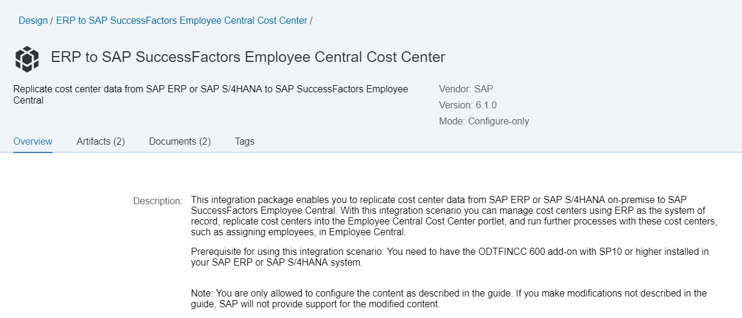

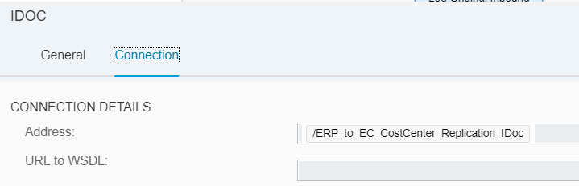

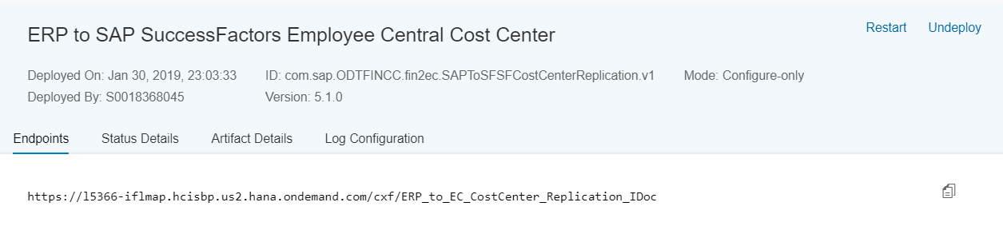

RFC Destination Name: EC_COST_CENTER_STANDARD

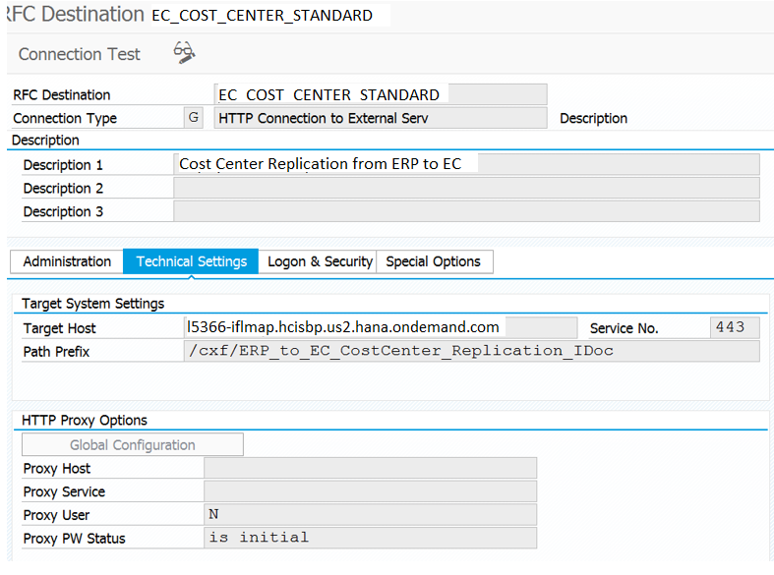

Port Name: CC_HCI

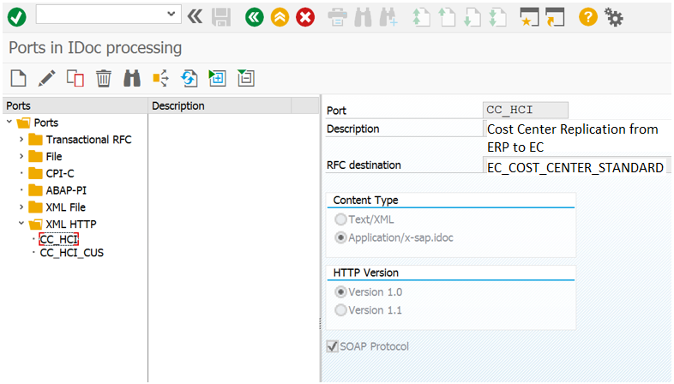

Partner Profile Name: EMPLOYEECC

Note: It is same for the both standard and custom iFlow’s.

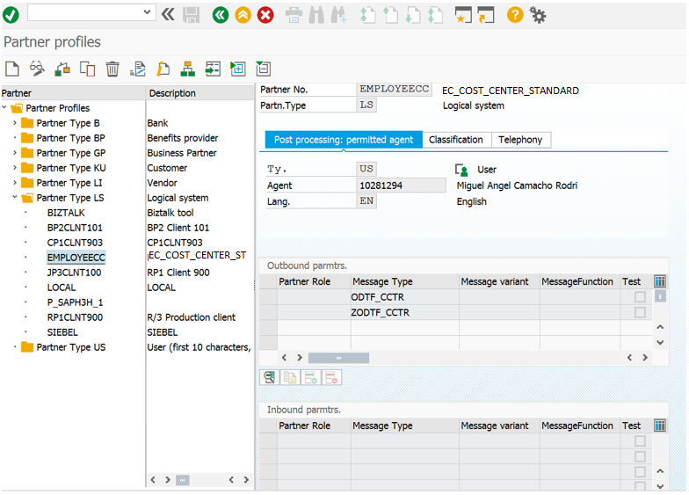

1. **Custom iFlows**

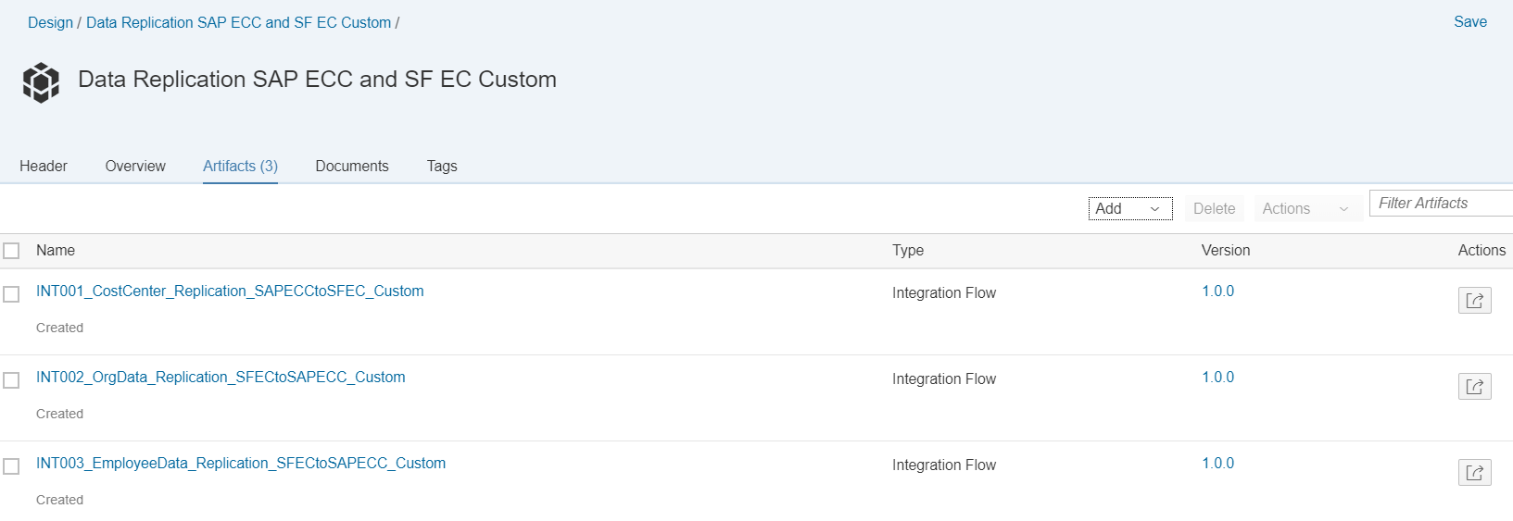

1. **INT001_CostCenter_Replication_SAPECCtoSFEC_Custom**

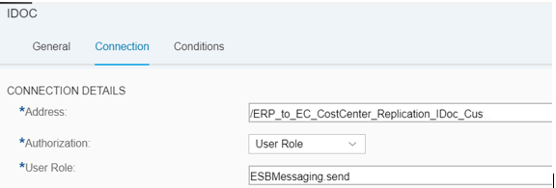

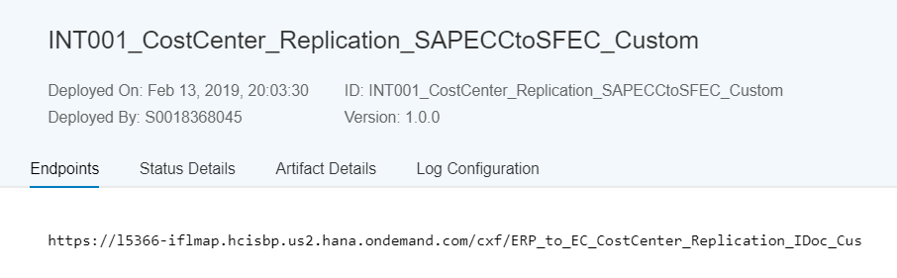

RFC Destination Name: EC_COST_CENTER_CUSTOM

Description: Cost Center Custom Replication from ERP to EC

Target Host: l5366-iflmap.hcisbp.us2.hana.ondemand.com

Path Prefix: /cxf/ERP_to_EC_CostCenter_Replication_IDoc_Cus

Port Name: CC_HCI_CUS

Content Type: Application/x-sap.idoc

Partner Profile Name: EMPLOYEECC

1. **INT002_OrgData_Replication_SFECtoSAPECC_Custom**

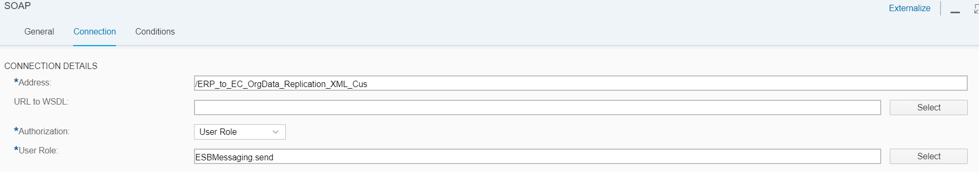

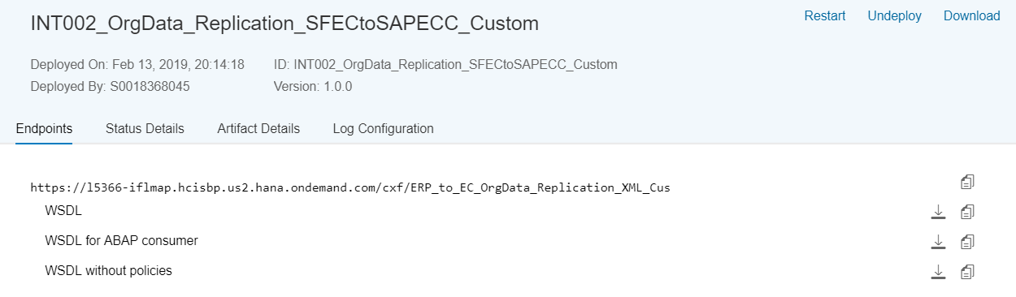

RFC Destination Name: EC_ORG_DATA_CUSTOM

Description: Org Data Custom Replication from EC to ERP

Target Host: l5366-iflmap.hcisbp.us2.hana.ondemand.com

Path Prefix: /cxf/ERP_to_EC_OrgData_Replication_XML_Cus

Port Name: ORG_HCI_CUS

Content Type: Text/XML

Partner Profile Name: EMPLOYEEORG

1. **INT003_EmployeeData_Replication_SFECtoSAPECC_Custom**

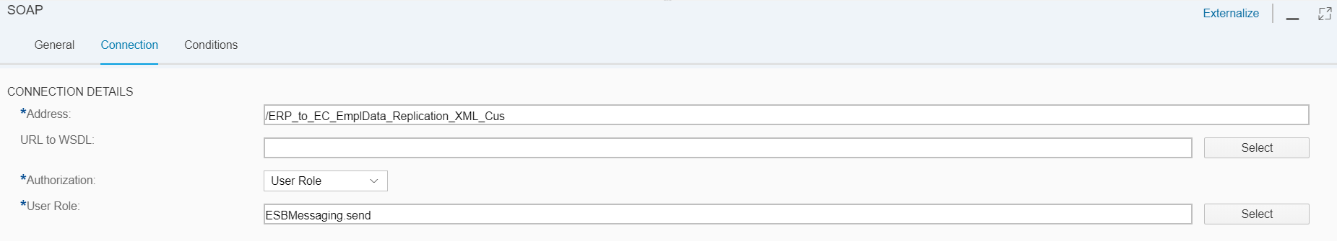

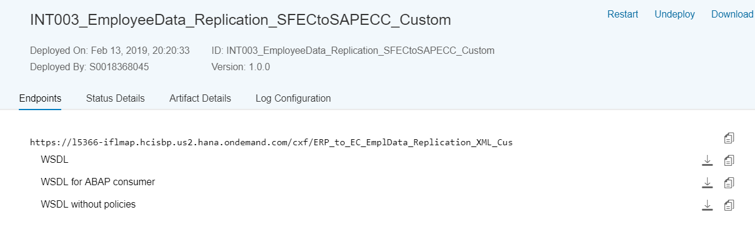

RFC Destination Name: EC_EMPL_DATA_CUSTOM

Description: Employee Data Custom Replication from EC to ERP

Target Host: l5366-iflmap.hcisbp.us2.hana.ondemand.com

Path Prefix: /ERP_to_EC_EmplData_Replication_XML_Cus

Port Name: EMPLDATA_HCI_CUS

Content Type: Text/XML

Partner Profile Name: EMPLOYEEDATA